Auto Ticket Classification using Flow Designer
PHASE 5: Project Development Phase

1. Backend Development & Configuration
The development phase implements the planned design in ServiceNow. The work includes custom table creation, field configuration, dependent choices and Flow Designer automation.
2. Custom Table Creation
- Open All menus and search for Tables.
- Under System Definition, select Tables.
- Click New.
- Create the Incident Workflow table.
- Disable Create module if required by the project configuration.
- Save the form and configure Auto Number.
- Create the required fields through the form configuration.
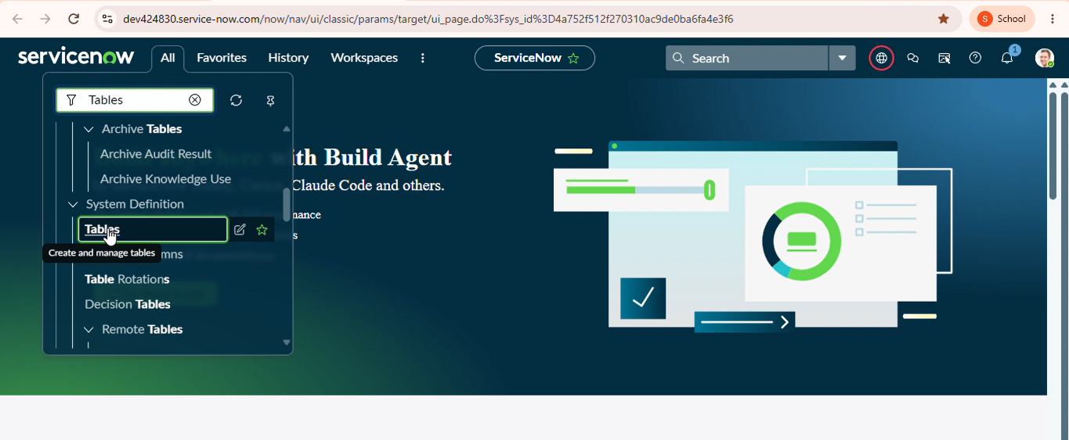
3. Field and Choice Configuration
The required fields are created with appropriate data types. Choice values are added for Category, Subcategory and State.
4. Flow Designer Automation
- Create a flow named Auto Classify School IT Tickets.
- Use Record Created as the trigger.
- Use Incident Workflow as the table.
- Set the condition to Category is empty.
- Create If / Else If branches for Wi-Fi, Projector, Password and Slow Computer issues.
- Update Category and Subcategory according to the matched keyword.
- Add a Send Email action to notify the caller.

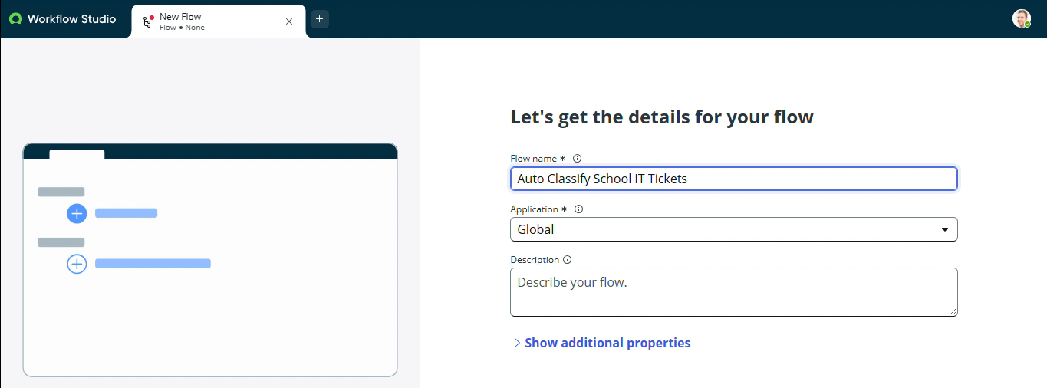

5. Classification Logic
Condition | Category | Subcategory
WiFi / Network | Network | Wi-Fi
Projector | Hardware | Projector
Password / Login | Access | Forgot Password
Slow / Hanging | Performance | Slow Computer



